Marxan Exercise – Sept. 18, 2013

Introduction
This exercise will have participants running Marxan analyses using existing input data. The goal is to provide participants with practice in using this software for conservation planning decision support. Once an introductory analysis is completed, there will be several options for exploring the tool further through new analyses that will involve changing some of the input parameters. Marxan outputs will be displayed using ArcGIS.

Part 1: Reviewing the files

From the Z: drive, copy the “Marxan” folder and paste it on the C: drive. Open the “Marxan” folder, then the “inputs” folder. Inside you will find four input files. These are delimited text files, with .dat extensions.
- Pu.dat: the planning units file consisting of a unique id for each hexagon, a current status (i.e. whether locked in or out or are available for selection), and a cost for including each hexagon in the solution
- Spec.dat: the conservation features file that includes the conservation goal for that feature and a species penalty feature for not attaining that goal
- Puvspr.dat: the planning unit vs. species file that describes the amount of each conservation feature within each hexagon
- Bound.dat: the boundary file listing the boundary lengths between adjacent hexagons (for use with the boundary modifier)
Open these files using Notepad and take a minute to see how they are constructed. Open ArcMap and add the shapefile “Hex100haBirds”. Open the attribute table and find the field “PU_ID_INT”. This will be used to join Marxan output tables for displaying via map.

Part 2: Inedit.exe

Inedit is the interface used to construct the input.dat file, which in turn guides Marxan when it is running. While it is possible to directly edit input.dat, many times it is easier to use the Inedit interface. We will go through each of the seven tabs found in Inedit, some in more detail than others. This exercise will only cover some of the parameters found here. For more information, see the Marxan User’s Manual. Double click Inedit.exe to start the program.

Tab1 – Problem
- Repeat Runs: This is used to set the number of runs Marxan performs. This parameter determines the range of irreplaceability scores, i.e. the “summed solution”. The higher this number, the greater the likelihood of finding low cost solutions. However, the converse is that computer run time increases with more runs. For this exercise use 10 runs (to same time), but generally it is preferable to use more than this.
- Boundary Modifier: Set the boundary modifier here. The higher the number, the greater clumping of planning units in the solution. You will need to experiment with this number to determine a suitable modifier. Set the BLM = 1 for this exercise.

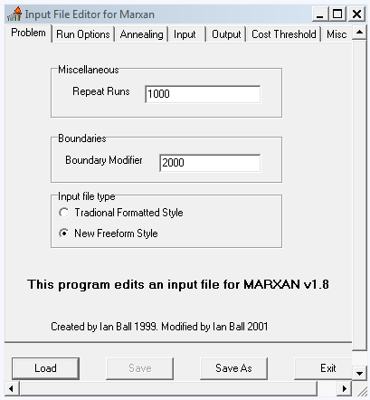

Tab 2 – Run Options
- Select the algorithm to use on this tab. While “Simulated Annealing” with “Iterative Improvement” are typical selections, there are other options as well. See the User’s Manual for details.

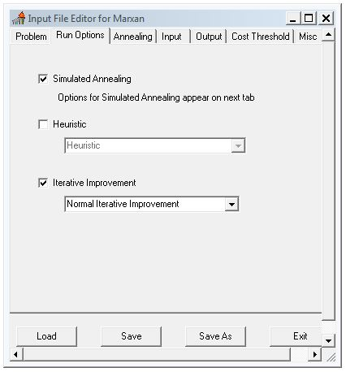

Tab 3 – Annealing
- Number of Iterations: This parameter describes the number of combinations of planning units that Marxan assesses in each run. A higher number increases the likelihood of low cost solutions being identified. A sufficiently high number is required to account for the random seed at the beginning of each Marxan run. For this exercise, start with 50,000,000 iterations,
- The temperature parameters control the Marxan feature that allows the software to select lower scoring combinations of planning units early in each run in order to avoid “local minima”. See the user’s Manual for more details.

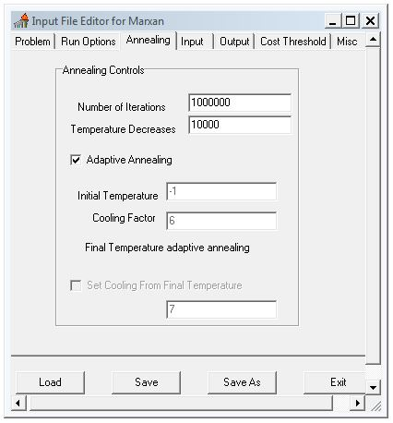

Tab 4 – Input
- Input Directory: Select the folder where the input files are located (these need to be in the same folder). For this exercise use the “inputs” folder in the “Marxan” folder.
- Browse to find the appropriate files for each file type. Note that they can be named anything, and that this is where their function in Marxan is determined. For this exercise use the file names below.

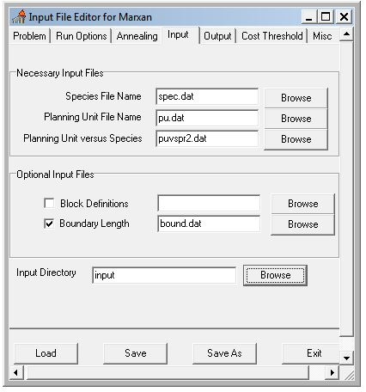

Tab 5 – Output
- Indicate which output files you would like Marxan to produce. We recommend as outputs at least “Overall Best”, “Summary”, “Summed Solution”, and “Log File”.
- Save File Name: This is the prefix to be used in all of the output files. If you are conducting more than one analysis with results going to the same folder, be sure to change this prefix, or the older results will be overwritten and lost.
- Output Directory: Indicate here where the output files should be saved. For this exercise choose the “outputs” folder in the “Marxan” folder.

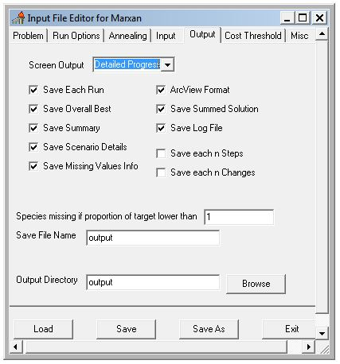

Tab 6 – Cost Threshold
- Enabling the cost threshold turns the Marxan “minimum covering set” problem into a “maximum coverage” problem. Here the user defines the cost ceiling above which no more planning units are selected without penalty. See the User’s Manual for details.

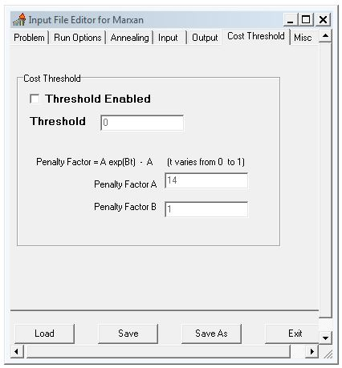

Tab 7 – Misc
- This tab contains several miscellaneous parameters. Most are associated with the conditions under which Marxan starts each run. For example, Starting Prop is the proportion of planning units randomly allocated to “protected” at the start of a run. See the User’s Manual for more information on these parameters.

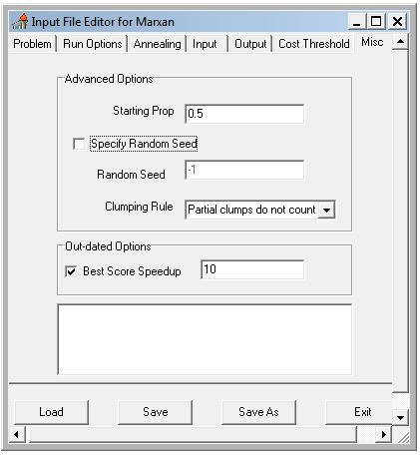

Once you have entered all of the parameters you wish to, click “Save” (this updates input.dat), then “Exit”.

Part 3: Input.dat

Input.dat is also a text file. It records all of the parameter decisions you made in the Inedit process. Open it using notepad. Here is an example of what it looks like:

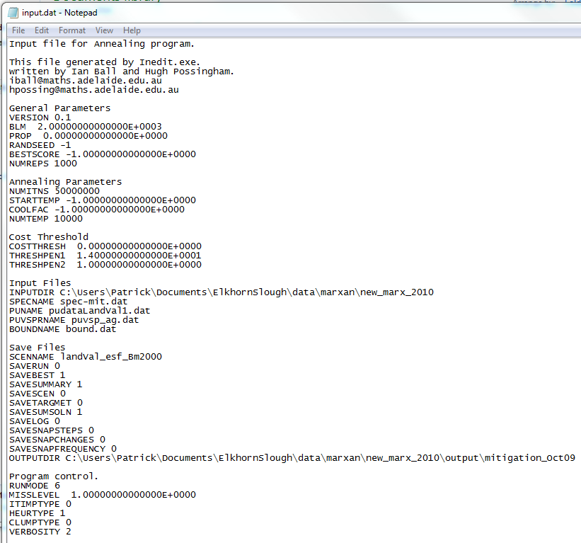

Be sure to review it for correct parameters. Close the file when you are finished.

Part 4: Running Marxan

Now you are ready to run Marxan. Make sure the file Marxan.exe is in the same folder as input.dat and Inedit.exe. Double click Marxan.exe to launch the software. Once the program starts it automatically runs until all of the runs are complete. When it has finished running, close the program.

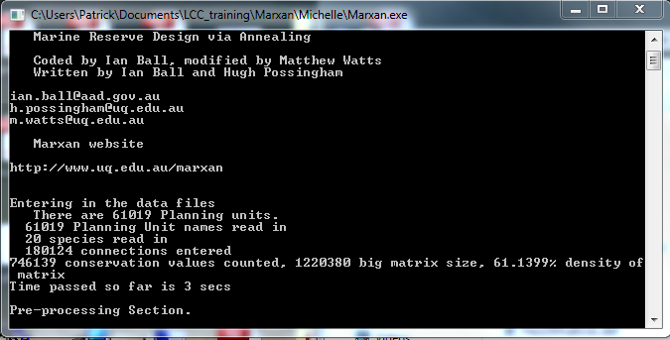

Part 5: Output files

These files will be found in the “outputs” folder. These will mostly be .txt files; open them using Notepad to see what information they contain.

To display the outputs, go to ArcMap. Join best.txt to the planning units shapefile using “pu_id_int” and “planning units” fields. Display the results using the “solution” field. A “1” indicates that the planning unit was part of the lowest cost solution. Remove this join and conduct a new join with ssoln.txt. Display using the “number” field to see each planning unit’s summed solution score.

Part 6: New Marxan runs

Choose a parameter to change. Try BLM, iterations, Starting Prop, etc. Compare the results with those from the previous analysis. Don’t forget to change the prefix in the Output tab, or your previous results will be overwritten.

