Systematic Conservation Planning Workshop Exercise: Cliamte Change

Introduction
In this activity, you will be running a Maxent model of sandhill crane habitat suitability under current climate conditions and potential future climate conditions.

The data used in this activity are for educational purposes only, and in some cases may lack the quality required to produce accurate and precise results.

Part 1: Data exploration
To predict to future climate conditions you need to develop a model under current conditions and then apply that model to environmental conditions that represent the future condition. In our case, we have ascii grids that represent future climate conditions of the area we are interested in (California). As a part of the data exploration, let us take a look at one environmental variable at current conditions and at future conditions as a comparison. Below is maximum temperature in spring (tmax) for current conditions (left) and the future conditions (right). They are displayed on the same color scale:

CURRENT FUTURE

Before we run our model, it would be prudent to check the correlation structure for the environmental variables under current conditions and compare those to the future conditions. As you know, one of the assumptions of the statistical correlation models is correlations remain constant to which the models are projected.
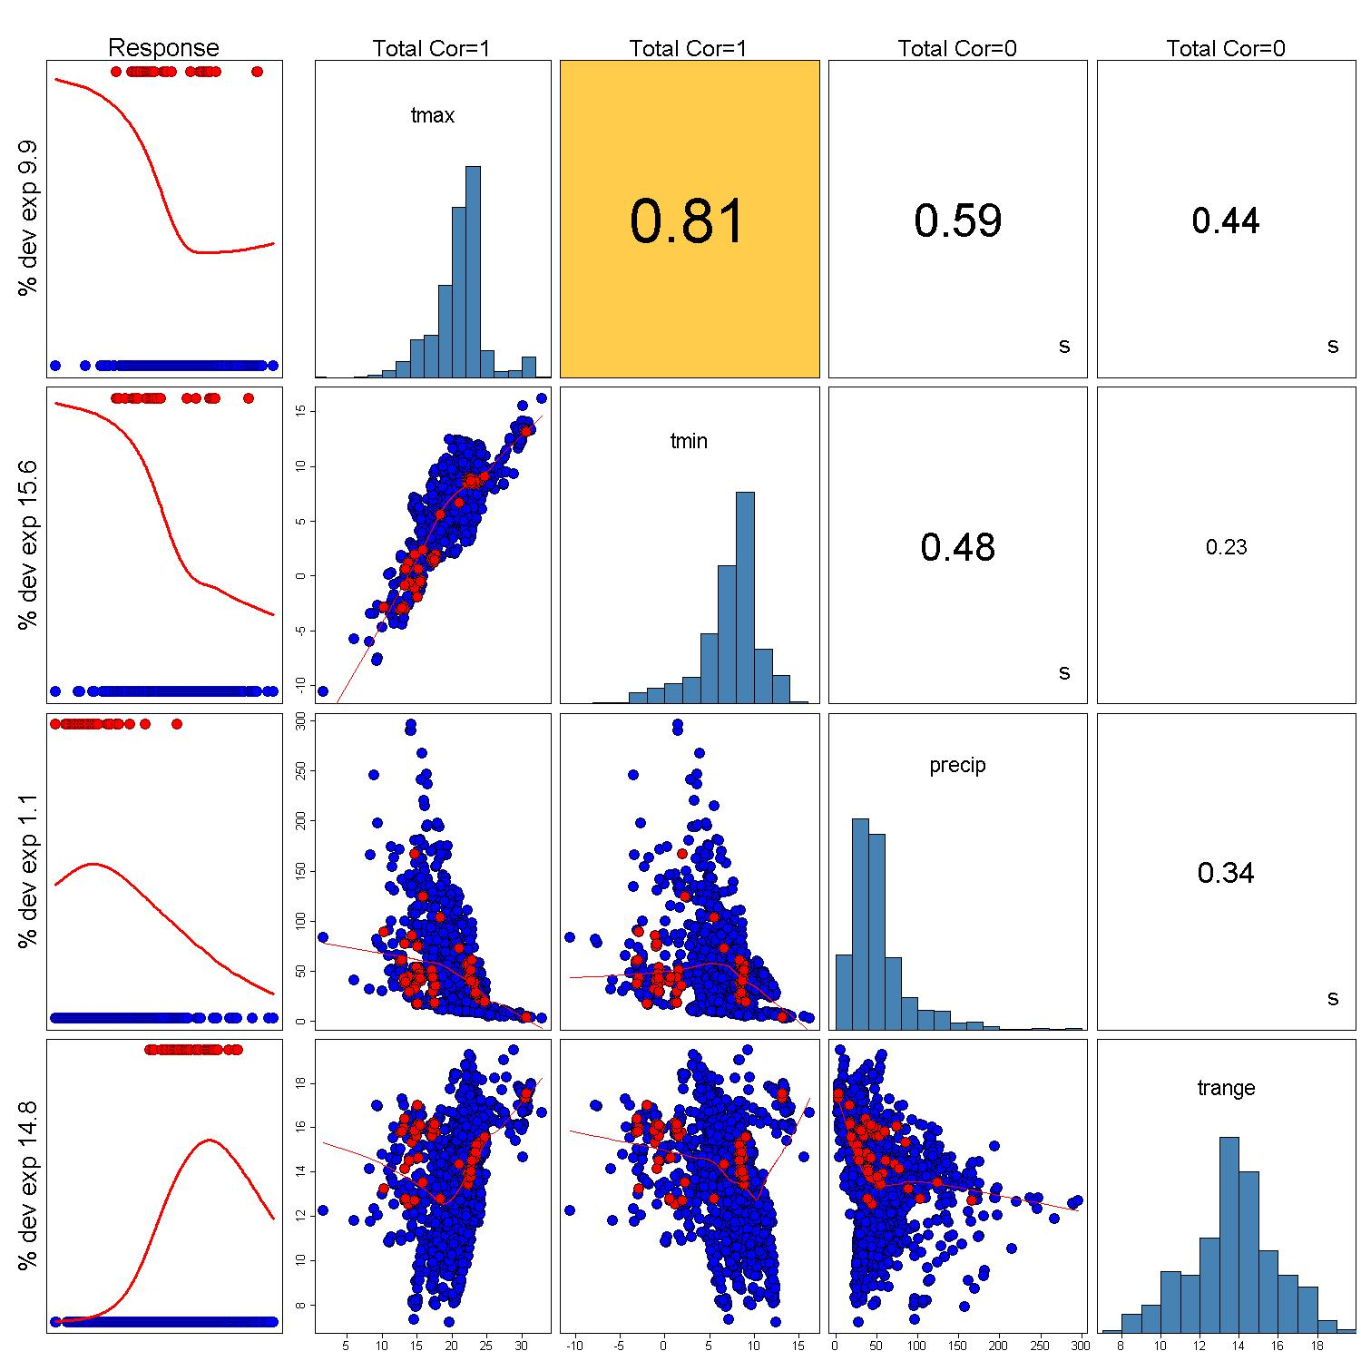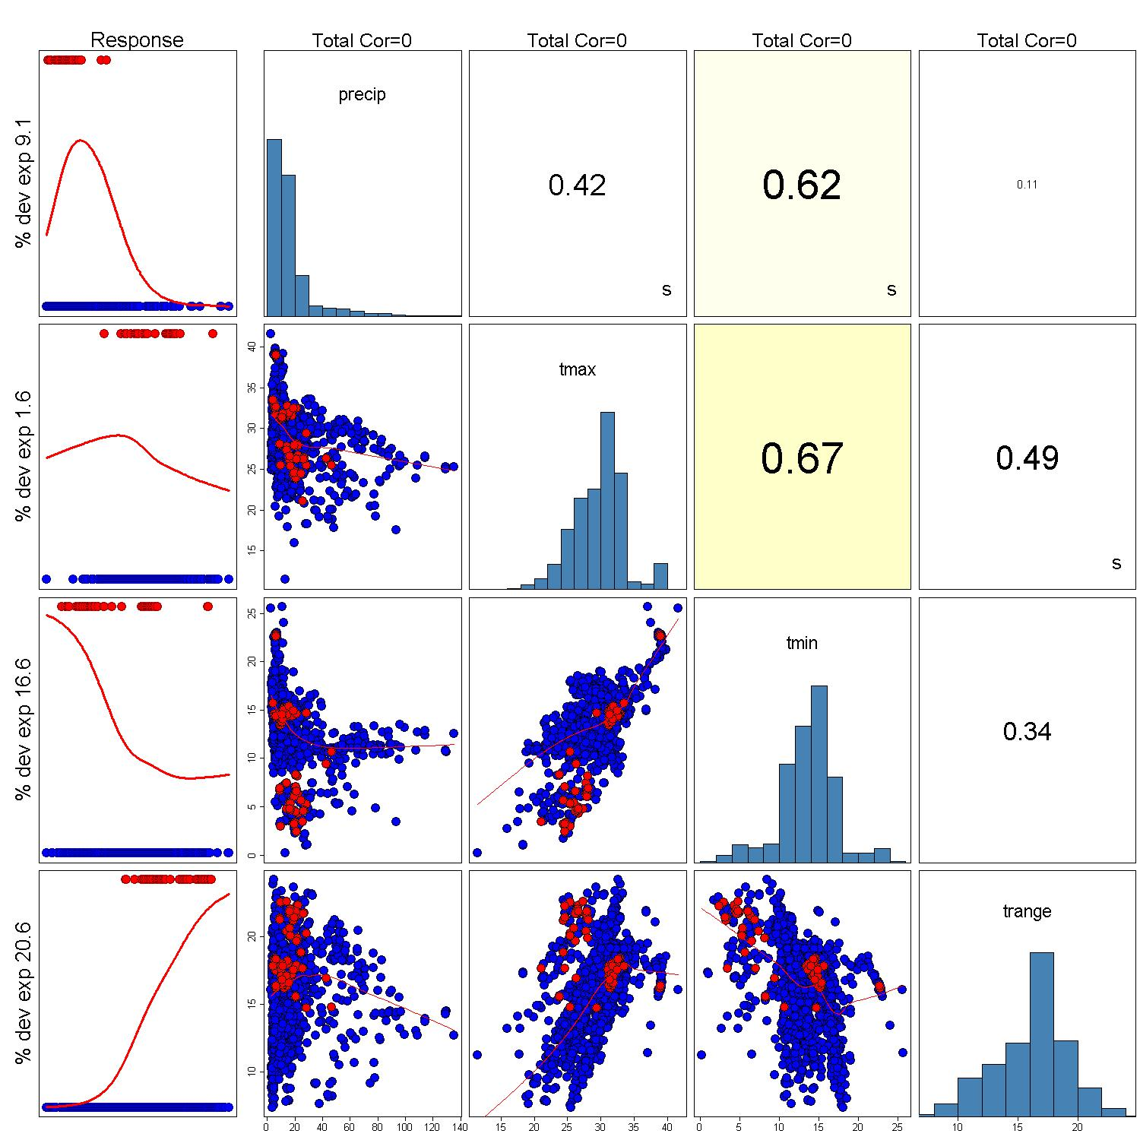
CURRENT FUTURE

Part 2: Developing and applying the model

We will be using the same data that we used for the Maxent activity for this exercise.

First, set the Samples file to be the Grus_canadensis.csv within the Workshop_StartData folder. Again, we will be using the ‘Samples With Data’ (SWD) format to run this model.

Set the Environmental Layers file to point to the spring_background.csv file in the Workshop_StartData folder.

De-check the landcov variable from the list.

Check the Create response curves

Create a new folder called FutureClimateOutput and set this folder as the Output directory for the Projection layers directory, change this to point to the EnvironmentalData folder. Then, we will want to add the path of the future climate environmental data set we have (CSIRO_MK3_0_B1). This data set is located in the FutureConditons folder. You can only set one folder using the browse button, so the path to the future conditions folder will have to be manually entered separated by a “,”. So for example:

ExamplePath\Workshop_StartData\EnvironmentalData, ExamplePath\Workshop_StartData\FutureConditions\CSIRO_MK3_0_B1

Your Maxent GUI should look similar to the one below
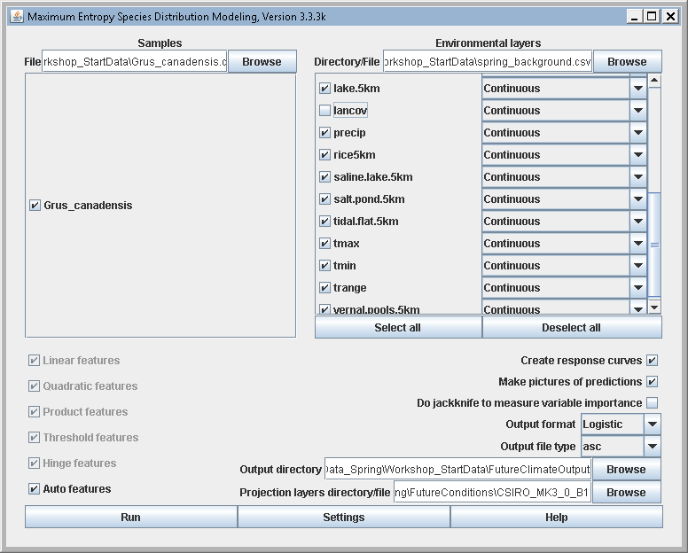

In the settings options,

De-select Removed duplicate presence records

De-select Write clamp grid when projecting

Change the Regularization multiplier value to 2
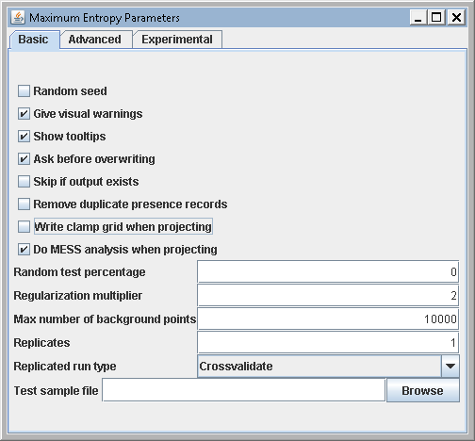

You won’t need to change any other parameters in the settings. Ideally, we would also run a method of model testing, but to speed up the model execution time, we will not withhold any data for testing

Hit Run

Once the model has finished, take some time to review the output in the html file.

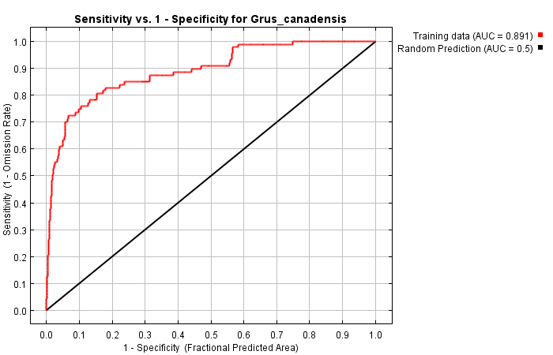

First, we can look at the AUC evaluation. The model is not much different than those we ran earlier in the workshop. Therefore, we would not expect a difference in the AUC evaluation for the main model.

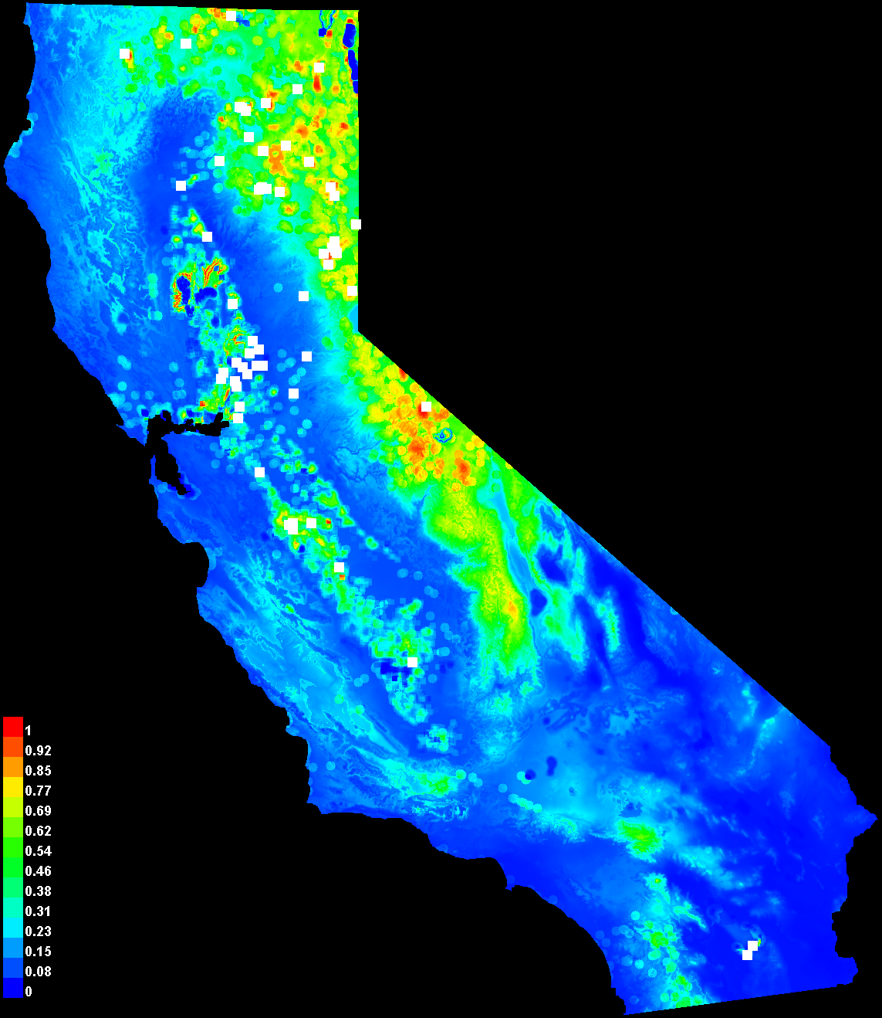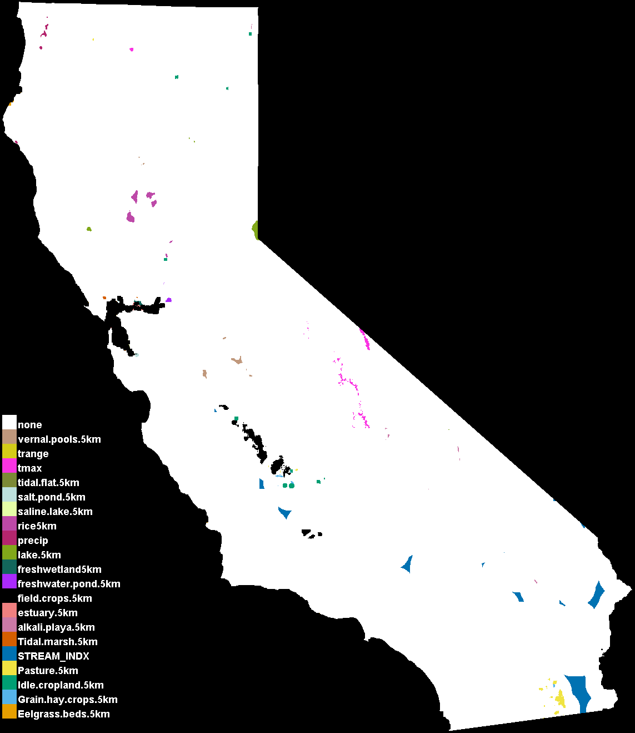

We can then look at the current condition model predictions along with the novel environments. Again, these maps should look similar to those you ran earlier in the workshop.

Further down the page we can take a look at the habitat suitability predictions under future conditions

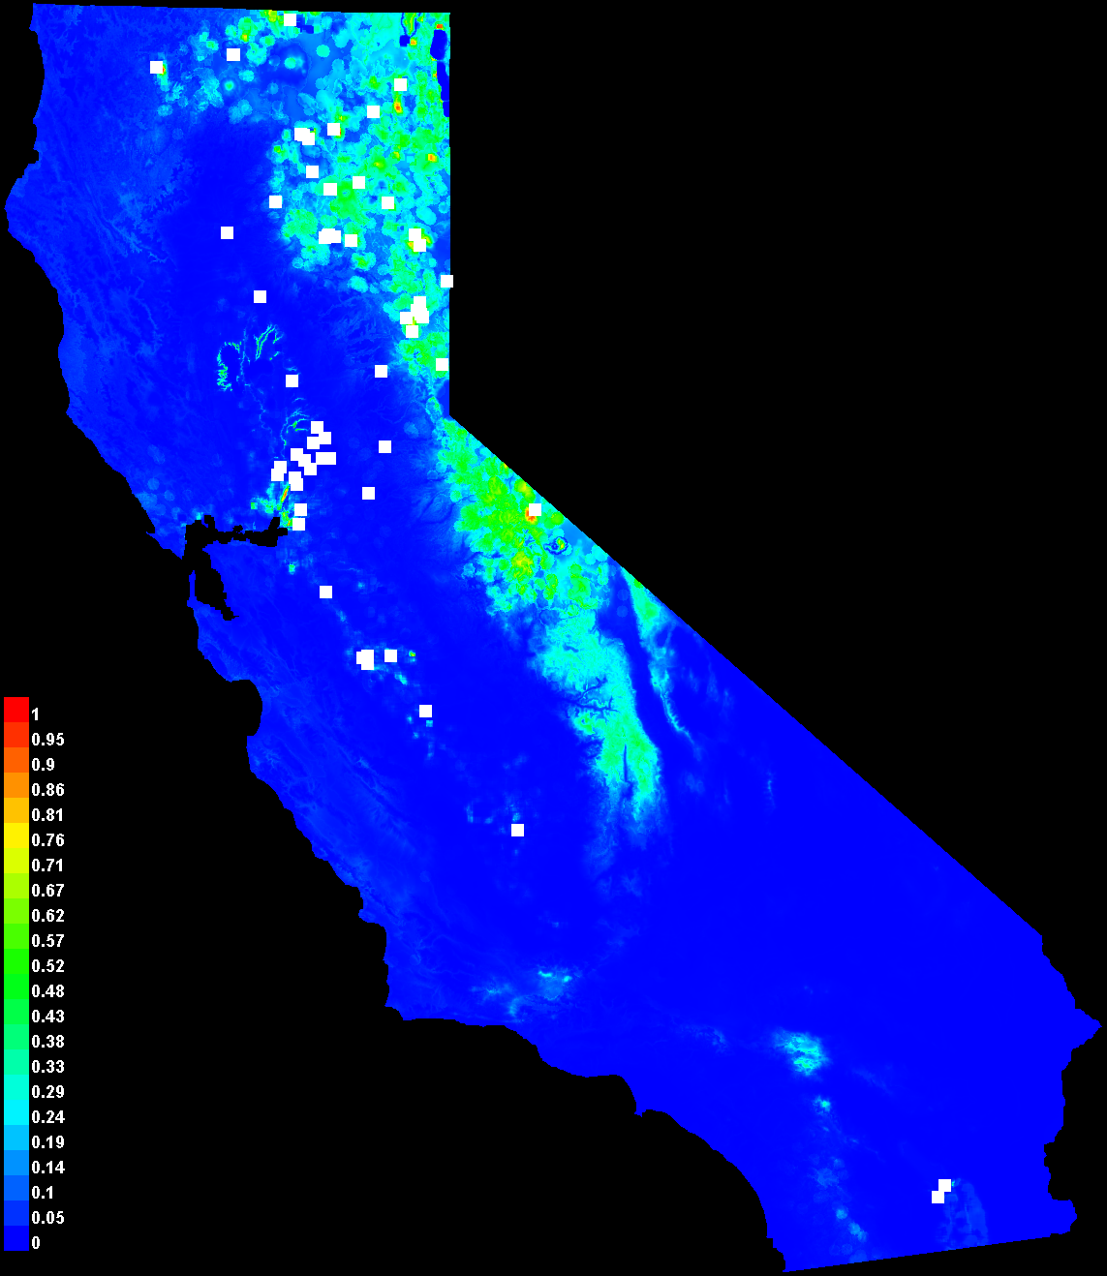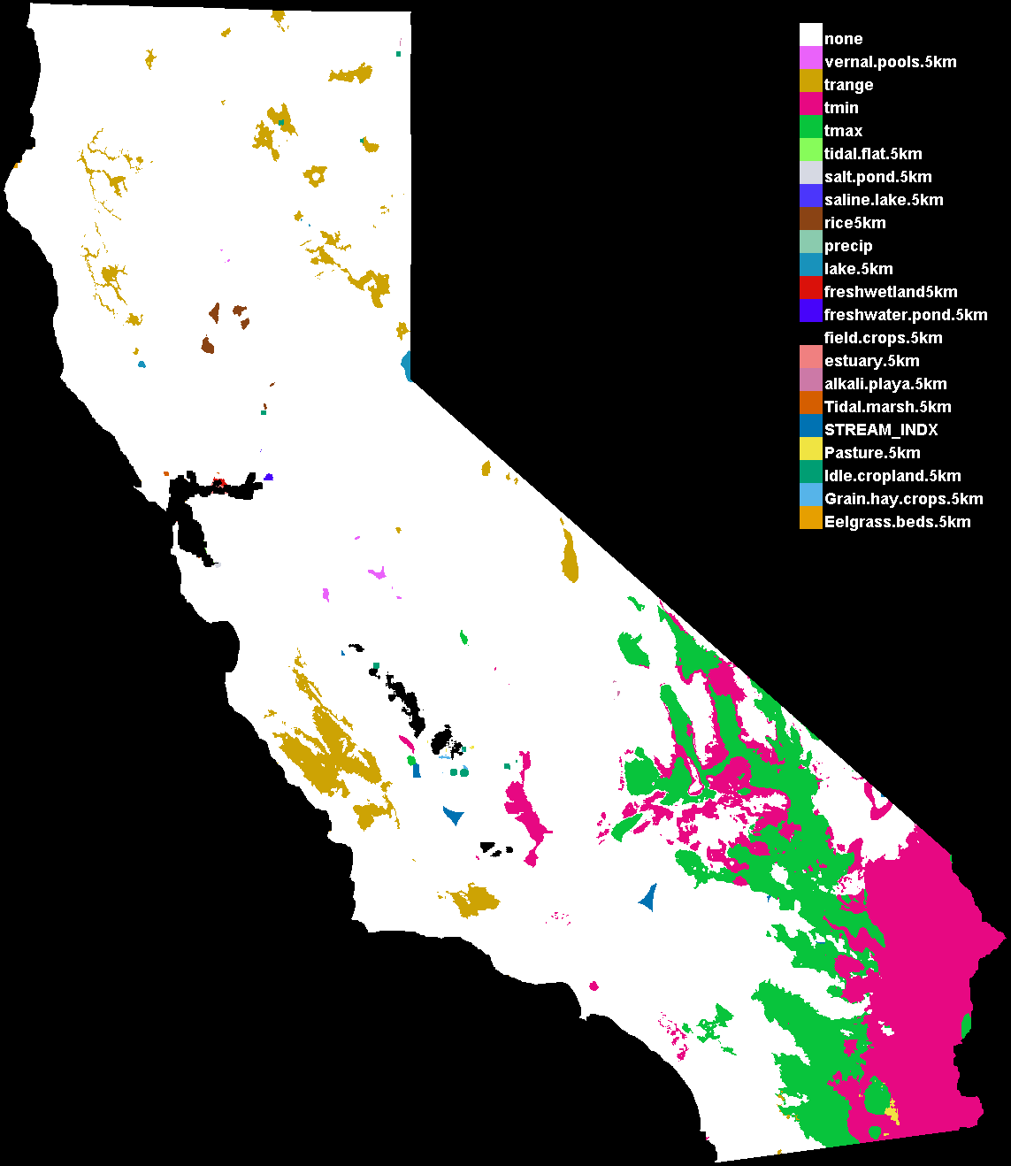

- What are some of the major differences between the predicted habitat suitability maps between current conditions and future conditions?

- What is the difference in the amount of novel conditions between current conditions and future conditions?

- What would be a way to possibly reduce the amount of novel conditions in the future conditions?

- How might the combination of these two results inform conservation actions related to this species?

