Systematic Conservation Planning Workshop Exercise: Understanding and Assembling Model Input

Introduction
In this exercise, we will demonstrate the many data acquisition and pre-processing that are generally required for systematic conservation planning analysis. These exercises are designed to provide a guide on some of the most common steps that are performed before more advanced analyses.

The data used in this activity are for educational purposes only, and in some cases may lack the quality required to produce accurate and precise results.

Part 1: Acquiring Occurrence locations
There are many online and free sources to find spatially reference species occurrences. These range from local to global and can be a valuable source of data. Here, we will demonstrate how to download occurrences locations for Grus canadensis from the Global Biodiversity Information Facility (GBIF)

Go to http://www.gbif.org/
On the right side of the page you should see a big “access data portal” button. Click this link.

Search for Grus canadensis in the search box. The next page is a terms of use page, Accept the terms.

You will see a list of a variety of results. For this purpose, let’s say we are only interested in the lesser Sandhill crane (Grus canadensis canadensis). Select this subspecies from the list.

This will bring you to a page with some taxonomic and distribution information. Scroll down to look at the global map of occurrences for a quick inspection.

At the top of the page there is a box titled “Actions for Grus canadensis canadensis”. Click on the Occurrences link under Explore:

On this next page, we could add some filters to only include a certain institution for example. We are interested in the full dataset, so we won’t provide any filters. Scroll down to the Actions section and select Spreadsheet of results under Download:

The next page provides a variety of options for the downloaded data format. From a selection of the specific attributes to include to the type of file the data will be delivered as. Choose Comma Separated Value format and leave the rest of the defaults. Click the Download Now button at the bottom of the page

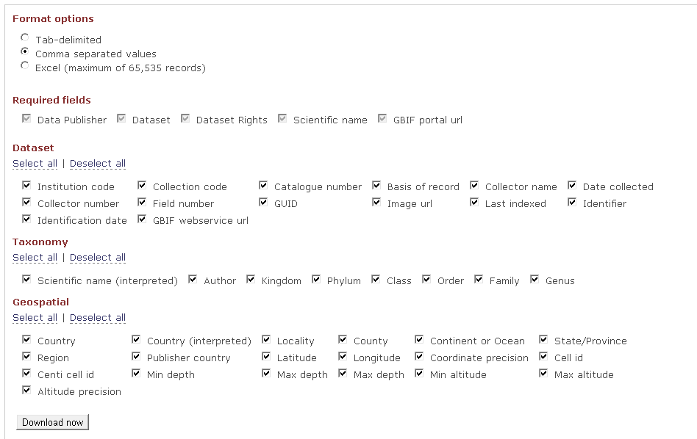

You’ll be brought to a download page that will let you know when your request is available for download.

Save the file in the Workshop_StartData. The data comes as a zipped file that will need to be extracted (unzipped). Extract the files to the same location and open the .csv file for inspection.

- What is the coordinate reference system of the data? How would you find this out?
- How many records don’t have any coordinates?
- Are there any duplicate records?
- How many records are unique?
- What are some field that might help provide a measure of data quality/accuracy
- What is the accuracy of a location with a latitude of 31.9 vs. 29.73457? How might this impact any analysis performed with these data?
- Below is the map of the occurrences. Are there any points the look suspect to further evaluation?

Part 2: Occurrence data exploration.
A critical step in any modeling exercise should be to explore the data that will be used for modeling. We are only going to touch on this subject but encourage rigorous evaluation of the data before proceeding to model generation.

First, open a new ArcMap document.

Load the Grus_canadensis_spring.shp file located in the Workshop_SartData folder that consists of occurrence points for Sandhill crane in the spring months. To help with a frame of reference, load one of the environmental data layers in the EnvironmentalData folder

- These data came from eBird which comprises of data contributed by volunteer and professional
  - What might be some concerns with this data set?
  - If you were handed this data set, what would be some questions you would ask to better understand the assumptions and limitations of the data?
- Are there any points that look suspicious?
- How many occurrences are there?
- Are there any duplicate locations? How might this impact a species distribution model? How might two occurrences that have the same location have different environmental data?

Part 3: Attributing environmental data to background locations.

Now that you have examined the sample file, you need to make sure that you have the background data prepared for Maxent. We will discuss this subject more later in the workshop.

Step 1: Loading occurrences from a spreadsheet
First, open a new ArcMap document.

Add all the ascii layer in the EnvironmentalData folder. To do this, select the add data button and navigate to the EnvironmentalData folder within the Workshop_StartData folder. Add all the rasters to the map (you can add them all at the same time by selecting the first raster, holding the shift key and then click the last layer).

In order to perform the analysis to attribute the background data, you will need to convert the background file into a shapefile (.shp)

In the same ArcMap, select FileAdd DataAdd XY Data…

A new window will appear. Navigate to the spring_background_start.csv file. In the window you will need to make sure that the X field and the Y field are set to the correct columns in the csv file. Click OK.
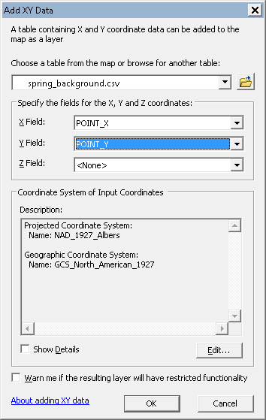

The background points should now be displayed on the map.

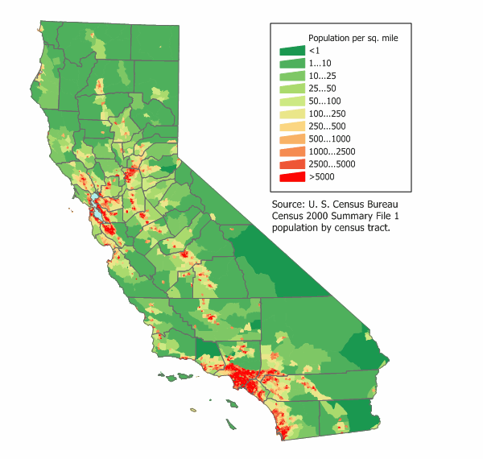
- What do you notice about the distribution of the background points?
  - Are they a random sample of the environment?
  - Where are they concentrated?
  - How is the distribution of the background points similar to the occurrence points?
  - These points represent all eBrid observations for all other species during the spring months. Why would we want to use these points as our background sample?

Step 2: Creating a shapefile

Next we will create a shapefile of these locations. Right-click the layer you just added called spring_background.csv Events Select DataExport data… A new window will appear. Click the folder icon for the Output feature class field to set the location and name of the shapefile. Save the file in the Workshop_StartData folder and name it Convert background file to point layer. Click OK.
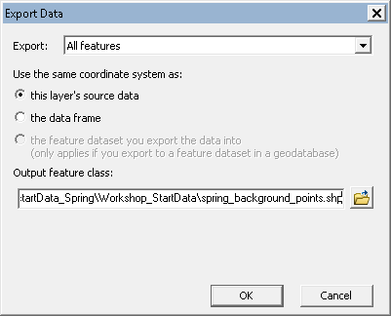
Once it has finished, it will ask you if you would like to add the layer to the map, select YES. You can remove the other Events layer at this point

Step 3: Attributing the background points

Now that we have both the background points and the environmental data loaded we will want to perform the attributing analysis using the Extract Multi Values to Points tool.

Search for “extract multi” in the Search window (this window may not be visible. If not, click on the icon in the toolbar or simply press ctrl+f). You should see the Extract Multi Values to Points tool as the first option listed. Select this item to open the tool.

For the Input point features, choose the spring_background_points.shp file. For the Input rasters field add all the environmental raters you added earlier. Click OK.

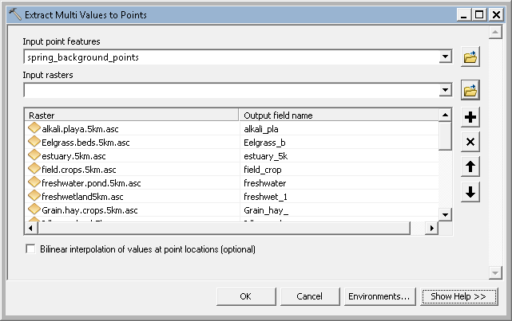

This may take some time to complete.

Step 4: Exporting a table and creating a comma separated value file

Once it has finished, open the attribute table for the spring_background_points.shp file. Export the table by selecting the table options icon Export…Save the file in the Workshop_StartData folder and name it “spring_background_export.dbf”. Make sure to choose dBASE file as the type
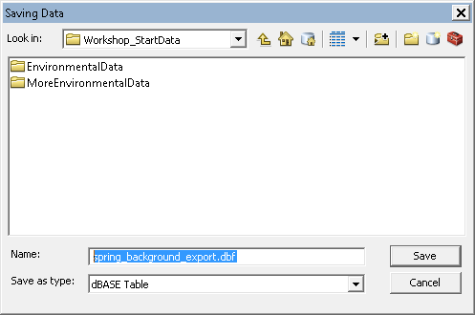

You will not need to add the table to the Map.

Next, navigate to where you saved the table file and open the file in excel. Remove any extra fields that may be present. The Maxent modeling software requires files to be in the comma separated value (.cvs) format. Select FileSave as… Save the file in the Workshop_StartData folder and name it “spring_background_forMaxent.csv” and make sure you choose Comma Separated Value (.csv) file format.

This file is now ready for Maxent modeling software.

- Take a look at the column names in the background sample spreadsheet. Do the match the original names of the environmental rasters?
- Maxent requires the names of the columns in the background file to match the file names of the environmental rasters. What would we need to do to make sure we don’t hit any errors when running Maxent

Part 4: Modifying Environmental Layers to be the Same Extent (geographic bounds and cell size) Using ArcGIS

Background:
This part of the tutorial walks you through the steps required to modify an environmental raster grid in ArcMap so that all your spatial environmental data (i.e., independent or predictor variables) have the same extent and resolution (same geographic bounds and cell size). MaxEnt requires all the environmental layers be in raster format and have the exact same cell size, extent, and projection system (e.g., geographic or UTM) in order to execute a model.

We will be using just one layer to demonstrate this example

Step 1: Loading layers into ArcMap and opening the Extract by Mask tool
Open a new map in ArcMap. Click on the add data icon and navigate to the MoreEnvironmentalData folder. Add the us_tmax_2010.05.tiff file. As a comparison, load one of the layers in the EnvironmentalData folder

- How do the file formats between the two layers compare?
- What is the extent of the us_tmax_2010.05.tiff and how does this compare to the other rasters?
- Check the grain (cell size) of the two layers – any differences?
- What about the coordinate reference system between the two layers?

Obviously there are some difference that we will need to correct if would like to include this raster in our modeling process.

Step 2: Re-projecting the match coordinate reference systems

First you will have to re-project the us_tmax_2010.05.tiff to match the rasters. To accomplish this, use the re-project tool in Data Management ToolsProjections and TransformationsRatterProject Raster. Open this tool. For the Input Raster, add the us_tmax_2010.05.tiff file. The Input Coordinate system should automatically be filled. For the Output Coordinate Dataset, Save the file in the MoreEnvironmentalData folder and name it us_tmax_10_5P. For the Output Coordinate System, use the NAD_1927_California_Teale_Albers projection (Projected Coordinate SystemState Systems). Once you have this filled out, click OK.
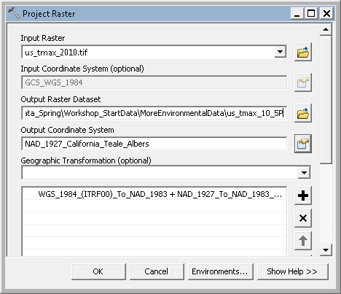

Step 3: Converting a raster to ASCII
Now we need to convert the file format from tiff to ASCII. We will accomplish this by using the Raster to ASCII too.

In the Toolbox window double click Conversion Tools then From Raster, and then double click on the Raster to ASCII tool.
For the Input Raster click on the folder icon and navigate to the us_tmax_10_5P file in the MoreEnvironmentalData folder.
For the Output ASCII raster file, click on the folder icon and navigate to the same MoreEnvironmentalData folder but name the file us_tmax_10_5c. Make sure to change the Save as type from .TXT to .ASC. Click Save.

Now that we have out new environmental raster in the same coordinate reference system we will resample and clip the layer to match those we already have.

Step 4: Resampling and Clipping (extract by mask)

If your environmental layers happen to be larger than the area you are interested in modeling, this step allows you to clip them down to your area of interest and set all layers to have the same extent, cell size, and coordinate system (a requirement of MaxEnt). This step can also be used to set your extent, cell size and coordinate system if your environmental layers are already clipped.

To start, open the Extract by Mask tool (You can search for this tool or find it in the toolbox: Spatial analysts ToolsExtraction). A window should appear that looks like the one below for the Extract by Mask tool (location described above).

For the Input raster click on the folder icon and browse to the MoreEnvironmentalData folder and select the us_tmax_10_5c.asc raster.

For the Input raster or feature mask data field, use the icon to browse to a raster or polygon that represents the spatial boundary you intend to model. For our example this can be any layer in the EnvironmentalData folder

Save the Output raster as us_tmax_10_5f under the folder MoreEnvironmentalData. Note, because Arc requires a ESRI GRID output for this tool, another step of converting the output to ASCII would be required before including in with the others for Maxent modeling.
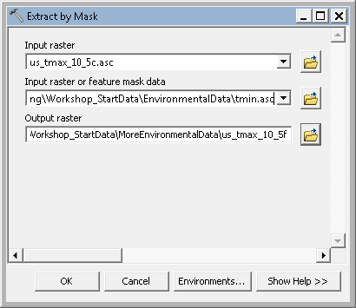

In order to set the cell size and extent, click on the Environments… button in the bottom right of the window*. Extend the variables Processing Extent, and Raster Analysis.

For the Processing Extent and Snap Raster variables, browse to a raster you know that already has the extent you wish to match (such as the one you used as the mask).

For the field of Cell Size under the Raster Analysis variable, choose the same layer as you did for the processing extent. The true cell size value will appear in the window below the input field. It will reflect the units from which your coordinate system is based.
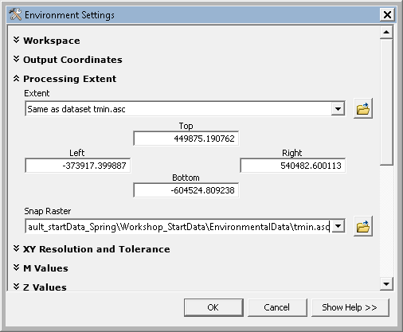
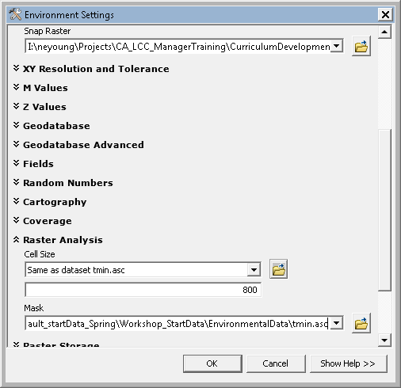
Click OK.

- Once the tool has finished running, check the properties of the output:
  - Do the number of rows and columns match the other layers?
  - Is grain size the size the same as the other layers?
  - Coordinate Reference System
- What might some issues with using this method for resampling? Are we forcing a downscale or upscale of our new raster?
- Is there only one way to resample?
- What if this was a categorical variable? How would we want to modify our methods to make sure we are using the appropriate resampling methods?

Part 5: Evaluating and removing Environmental data
In this section, you will examine the correlation structure of the environmental data in relation to the occurrence locations and background locations.

Collinearity is an important component to evaluate in the environmental layers. Below is a matrix of the environmental layers that we are considering for a spring distribution model for Grus Canadensis (Sandhill Crane) generated by another freely available tool, the software for assisted habitat modeling (SAHM). Note this only shows 8 of the 21 variables that we are considering for thee model. The remaining variables are not highly correlated.
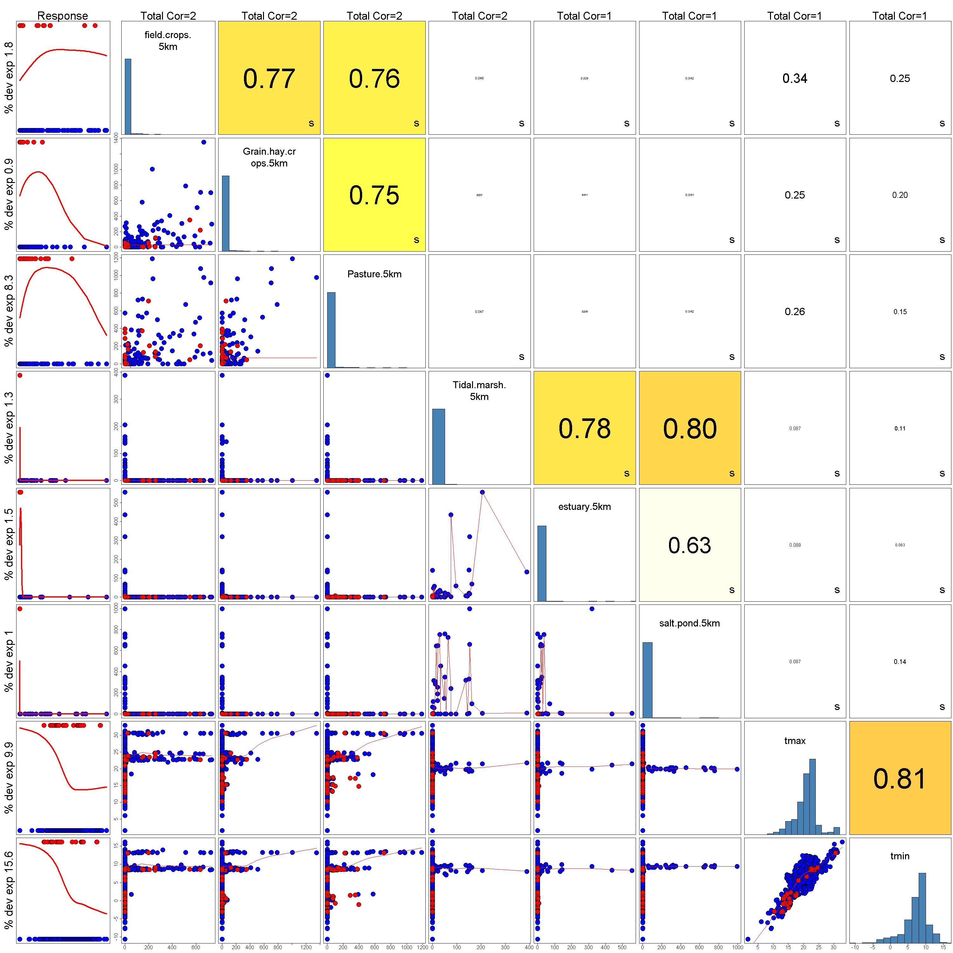

As you can see, some of the variables have higher correlations than others. The general rule of thumb for SDM is to remove one of each pair of highly correlated variables (R²>0.70). When choosing which variables to remove, always try to keep the variables that you know have ecological relevance to the distribution of the species for the system of interest. Depending what is known about the species and on your knowledge of the species, this may be easy or difficult and there might not be enough information to know which environmental variable may be more important. In this case you can remove the variable that is more easily interpretable, the one that explains the most deviance, but one should be removed before continuing to the model.

Spend some time deciding what variables you would remove and why. Write these down, you will use them later.

