**C:\Users\ccoghlan\AppData\Local\Microsoft\Windows\Temporary Internet Files\Content.IE5\2WPSDIPB\MC900310662[1].wmf**

**Key Points: Structured Decision Making Workshop June 2013**

***Case Study: Understory Management***

**Objectives**

* Fundamental: Maintain healthy populations of native vertebrates and invertebrates in understory of Ponderosa Pine forest
* Means: Maintain open canopy pine stand with appropriate understory vegetation

**Actions**

* Alternative actions: Prescribed understory fire and Mechanical thinning of understory
* Timing: How frequently and under what conditions?

**Models**

* Predict: how basal area and vegetation composition change as a function of time, treatment and how native animal communities change as a function of habitat conditions
* These models might be mental, conceptual, or quantitative - but should explicitly link actions to objectives

**Optimal Solution**

* Found by integrating objectives, actions, and models
* Identify the action and its timing that best achieve the objectives
* An optimal solution might call for, say, thinning whenever the basal area exceeds 85 ft2/ac

**Monitoring**

* Evaluation: Maintain open canopy (<60% closure) pine stand, with understory vegetation cover of 15-25% pinegrass, ≥5% elk sedge, <1% exotics.
* Management Trigger: A management prescription calls for thinning a Ponderosa Pine stand when the basal area is greater than 85 ft2/acre.
* Learning: What are the differential effects of mechanical thinning vs. prescribed understory fire on vegetation composition?

**Summary**

* Decision problem
* Objectives
* Actions
* Predicted consequences
* Analysis of trade-offs
* Additional steps, e.g., monitoring
* This is what is meant by structured decision making (SDM)

*Notes:*

**What is Structured Decision Making?**

* “A formal application of common sense for situations too complex for the informal use of common sense.” - R. Keeney
* “I used to think of decision analysis as common sense for solving difficult decision problems.”
* “Now I think that the more important role of decision analysis is a way of thinking through any of the decisions you face.”- R. Keeney

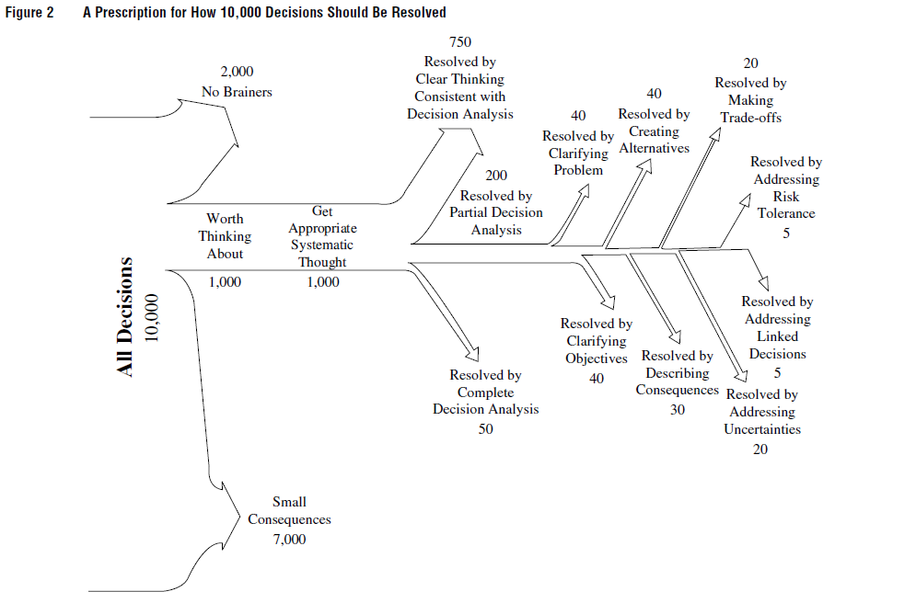

**What Makes a Good Decision?**  The result/outcome, the process, or something else altogether?

**What Makes a Decision Hard?**

* Sometimes you don’t know all the possible actions
* The objectives may be complex or contradictory, or in dispute
* The system dynamics may be poorly known
* Even knowing all the other components, the solution (optimization) may be difficult to figure out

**Two Key Elements**

* Problem decomposition: Break the problem into components, separating policy from science; Complete relevant analyses; Recompose the parts to make a decision
* Values-focused: The objectives (values) are discussed first, and drive the rest of the analysis. This is in contrast to our intuitive decision-making, which usually jumps straight to the alternatives

**When is SDM Appropriate?**

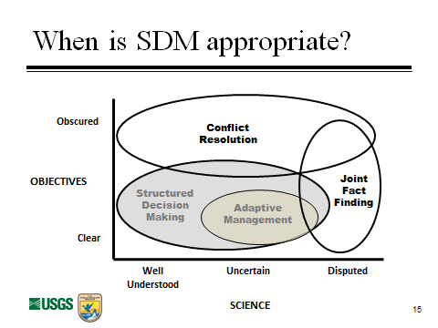

**What Decision is SDM Good For?**

* Tiny ones: 1 person at their desk, an hour; Fine-tuning an impoundment drawdown schedule
* Little ones: Field office, days to weeks; Bull trout Section 7 workload allocation
* Middle-sized ones: Regional problems, months of analysis; R4/R5 coordinated monitoring of migratory birds
* Big ones: National scope, years; Waterfowl harvest regulations, Major listing decisions

**Benefits of SDM**

* Decision processes that are transparent, explicit, deliberative, able to be documented, and replicable

*Notes:*

***Outline- PRoAct***

1. **Defining the Problem**
   * Who is the decision maker?
   * What are the legal and regulatory contexts?
   * Identify the decision’s essential elements
   * Scope and scale
   * Timing and frequency
   * Understand what other decisions are linked to this one

**Classes of Problems**

|  |  |  |
| --- | --- | --- |
|  | No Uncertainty | With Uncertainty |
| Single Objective | Management Science, Optimization Tools | Classic Decision Analysis; decision trees |
| Multiple Objective | Multi-attribute tradeoff tools and complex optimization | Multiple objectives tools with variable inputs |

*Notes:*

1. **Objectives** 
   * Explicit statement allows focused discussion, negotiation, and evaluation
   * Should capture implied trade-offs
   * The objective drives everything else
   * Focus on setting objectives first, before discussing alternatives
   * Constructed Preferences: In many important and complex decisions, preferences may not be fully formed; Elicitation and decision analysis processes may be the means by which decision-makers’ preferences become fully formed; The constructed preferences can be influenced by the methods of development

**Invasive Alewives in Lake Champlain Objectives Hierarchy**

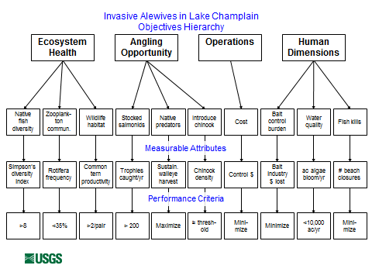

*Notes*:

1. **Alternative Actions** 
   * Sometimes the list of potential actions is clear - but often, generating such a list is the fundamental challenge and often the range of options initially discussed is unnecessarily narrow
   * Ask, how can the objectives be achieved?
   * Use the fundamental objectives to generate alternative actions to consider
   * Challenge apparent constraints
   * Don’t anchor on the initial set of options
   * Develop creative & unique alternatives before assessing feasibility and efficacy

*Notes:*

1. **Consequence (models)**

Predicting the Future: “…decision making is a forward-looking process….And if decision making is the attempt to achieve a desired future, then any such attempt must include, implicitly or explicitly, a vision of what that future will look like.” Sarewitz et al. (2000). Prediction: Science, Decision Making, and the Future of Nature. Island Press.

* The Role of Modeling
  + Models link actions to outcomes that are relevant to the objectives and make predictions
  + The decision context provides guidance about how to construct the model
  + There is a wide range of types of models

Consequence Tables

|  |  |  |  |  |
| --- | --- | --- | --- | --- |
| Objectives | Direction | Actions | | |
| Status quo | Alternative 1 | Alternative 2 |
| Objective A | Maximize | High | Medium | High |
| Objective B | Maximize | Low | High | Medium |
| Objective C | Maximize | Low | High | Medium |

|  |  |  |  |  |
| --- | --- | --- | --- | --- |
| Objectives | Direction | Actions | | |
| Status quo | Alternative 1 | Alternative 2 |
| Objective A | Maximize | 5 | 3 | 5 |
| Objective B | Maximize | 2 | 5 | 4 |
| Objective C | Maximize | 1 | 5 | 3 |

|  |  |  |  |  |  |
| --- | --- | --- | --- | --- | --- |
| Objectives | Direction | Actions | | | |
| Status quo | Minor Repair | Major Repair | Re-build |
| Cost ($M) | Minimize | 0 | 5 | 12 | 20 |
| Environmental Benefit (0-10) | Maximize | 1 | 3 | 10 | 10 |
| Disturbance (0-10) | Minimize | 0 | 1 | 7 | 10 |
| Silt runoff (k ft3) | Minimize | 3 | 1 | 5 | 5 |
| Water Retention (MG) | Maximize | 41 | 42 | 40 | 41 |

Decision Tree

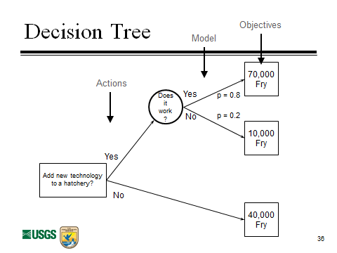

Influence Diagrams and Bayes Nets

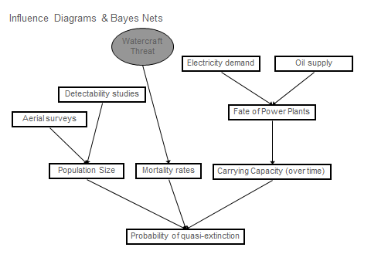

Habitat Models

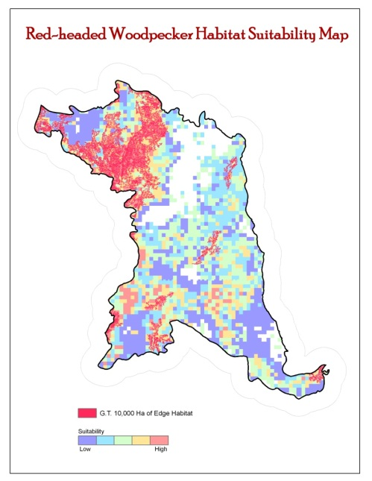Source Mary Mitchell, FWS/R3

1. **Trade-offs and optimization *Figures 8-10***

How do we “solve” a structured decision problem?

Optimization with Inspection

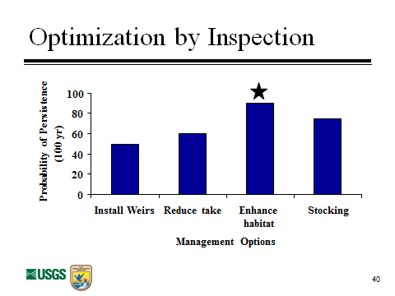

Single-objective Problems

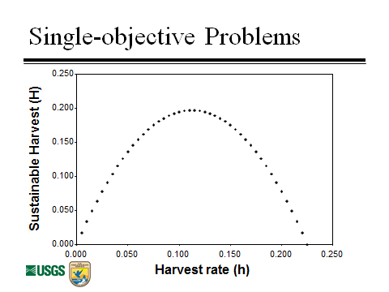

Multiple-objective Problems

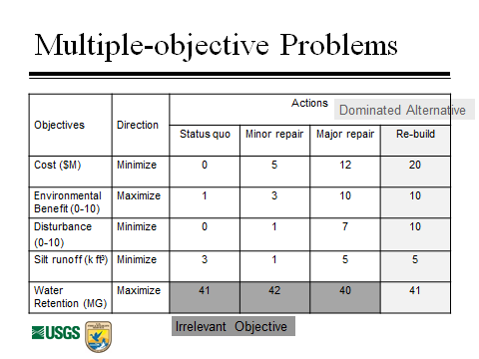

***Additional Steps***

1. **Recognize Uncertainty**
   * Smart choices don’t always result in good outcomes - Because of uncertainty
   * Need to explicitly build uncertainty into decision analysis
     + Quantitative expression of uncertainty
     + Risk attitudes: making decisions in the face of uncertainty about outcomes
   * Risk
     + All of the decisions we are faced with are made under uncertainty - therefore they contain risk
     + We need to be good at discussing and understanding risk
     + Need to understand the willingness of agencies and individuals to take risks
2. **Avoid Psychological Traps**
   * Making Choices: status quo bias, sunk costs, escalation of commitment, and confirmation bias
   * Assessing probabilities: anchoring and availability bias
3. **Linked Decisions** 
   * Often, we have a series of dependent decisions to make: A decision early on can affect the options available later, as well as the state of the system at a later time
   * Analyzing such decisions separately can lead to suboptimal decisions
   * Adaptive Management
     + All management decisions are made without perfect knowledge (this uncertainty contributes to making decisions difficult)
     + Any management decision can potentially provide the chance to learn
     + Iterated decisions can be adaptive

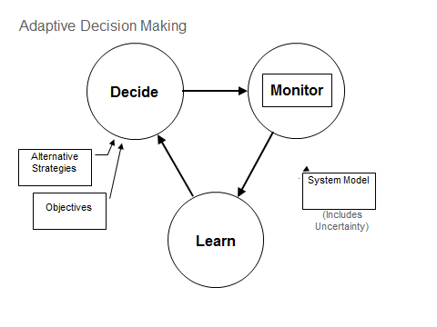

1. **Sensitivity Analysis**
   * Examine how the optimal decision and the expected performance is affected by assumptions, parameters in the models, levels of uncertainty, weights on objectives, and the problem framing itself
   * Ask whether the decision is robust to uncertainty. If not, consider revising aspects of the problem
2. **Review and Revise**
   * Decision analysis can be iterative - Develop a prototype, perform sensitivity analysis, revise as appropriate
   * Work from broad levels to details -get the framework right, first
   * Framing the Problem: hardest skill of all and the first step (requires being able to anticipate all the elements of the decision and getting a glimpse of the core decision problem)
   * Use the PrOACT+ framework and continually revisit the question

*Notes:*

***Summary***

**PrOACT+**

* A guide for defensible decision-making: problem decomposition and values-focused thinking
* Steps
  + Problem
  + Objectives
  + Actions
  + Consequences
  + Trade-offs

**Roles**

* Policy: decision maker, stakeholders, subject matter experts (e.g., legal)
* Science: subject matter expert (biological)and modeling expert
* Integration: decision maker, decision analyst, facilitator

**Goals**

* Improvement, not perfection
* We hope to use a structured process to improve the quality of our decisions but we don’t expect to ever be perfect and it’s difficult to escape our limitations as decision-makers

**Rapid Prototyping**

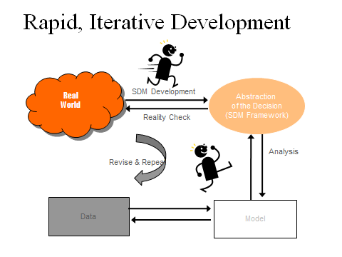

* Include all the elements of a structured decision, but keep them very simple (*sketch the decision*), focus on the key elements and use placeholders and guesses to keep going
* See how it works and check back to Real World – is this abstraction working and what needs to be improved
* You learn about and improve your framework by trying it: Build iteratively and increase complexity thoughtfully
* Low risk – high return approach. It doesn’t matter if you’re wrong the first time, you can start over with little loss. Don’t invest more than you need to and understand what you are doing

*Notes:*