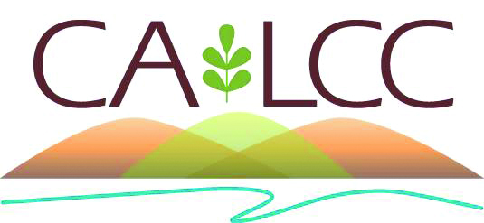
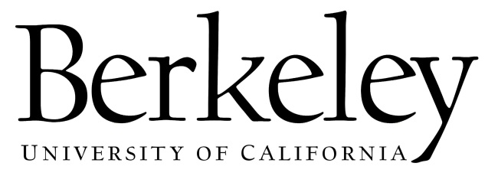

Climate Change Refugia Workshop
Objectives:
- Interface between natural resource managers and university and federal scientists to clarify whether and how refugia can be used as a tool for management and conservation
- Produce a review paper that highlights the use of climate refugia as a tool for management and conservation
Location: 103 Mulford Hall, University of California, Berkeley
Date: Wednesday, May 28 - Friday, May 30, 2014
Participants:
- Steve Beissinger, UC Berkeley
- Solomon Dobrowski, University of Montana
- Deanna Dulen, National Park Service
- Joe Ebersole, Environmental Protection Agency
- Lorraine Flint, USGS
- Alan Flint, USGS
- Jessica Lundquist, University of Washington
- Sean Maher, UC Berkeley
- Connie Millar, US Forest Service
- Bill Monahan, National Park Service
- Toni Lyn Morelli, University of Massachusetts/Northeast Climate Science Center
- Koren Nydick, National Park Service
- Kelly Redmond, Desert Research Institute
- Sarah Sawyer, US Forest Service
- Sarah Stock, National Park Service

Wednesday, May 28
8:30-9:00 Coffee and Pastries (Meet at 103 Mulford Hall)
9:00-9:30 Introduction and Overview
9:30-10:30 A Review and Discussion of Climate Refugia from the Literature and the Ground (Toni Lyn)
10:30-10:45 Break
10:45-12:30 Speed Talks: Operationalizing the climate refugia concept.
Presentations on participants’ research or experience with climate refugia. Alternatively, what do you like about the concept? What do you think doesn’t work?
12:30-1:30 Lunch – Tandoori Nite, 2160 University Ave
1:30-3:00 Panel Discussion: Perspective from the Federal Agencies
3:00-3:15 Break
3:15-4:30 Topic Discussions (Break into Section Teams) – 106, 107, & 240 Mulford Hall
5:00-6:00 Happy Hour – Jupiter, 2181 Shattuck Ave
6:00-8:00 Dinner - Jupiter, 2181 Shattuck Ave

Thursday, May 29
8:30-9:00 Coffee and Pastries (103 Mulford Hall)
9:00-10:00 Topic Presentations: Each section team presents their section thus far and what are the major topics for discussion
10:00-10:15 Break
10:15-12:30 Topic Discussions and Writing (Break into Section Teams)
12:30-2:00 Lunch – Saturn Cafe, 2175 Allston Way
2:00-3:15 Group Brainstorming
3:15-4:30 Topic Discussions and Writing (Break into Section Teams)
6:00-8:00 Dinner – Angeline’s Louisiana Kitchen, 2261 Shattuck Ave

Friday, May 30
8:30-9:00 Coffee and Pastries (103 Mulford Hall)
9:00-10:45 Topic Discussions and Writing (Break into Section Teams)
10:45-11:00 Break
11:00-12:00 Full group review of topics: Overview, management implications, utility of the concept
12:00-1:00 Lunch – Order in sandwiches
1:00-2:00 Full group review of topics: Theoretical processes, refugia identification
2:00-2:30 Presentation from Managers: What have you learned about how refugia can be used and what are the greatest agency needs around this topic
2:30-3:00 Summary and Next Steps

