Progress Report for Point Blue’s CA LCC funded projects
November 15, 2013
LCC Project: Vulnerability Analysis and Monitoring Program for Detecting Changes in SF Bay Tidal Marsh Bird Populations Resulting from Climate Change
- Initiated efforts to include elements of the climate change monitoring framework in the Bayland Ecosystems Habitat Goals Update Project Technical Report to be completed in 2014.
- Continued to work to ensure compatibility of the climate-change monitoring program with regional and national monitoring efforts (SFBJV, BAECC Climate Change monitoring, national marshbird monitoring plan).
- Nadav Nur made a presentation on this project at the Coastal and Estuarine Research Federation Meeting in San Diego, November 2013, as part of a Special Session on San Francisco Bay.

Project Title: An Improved Decision Support Tool for Adaptive Tidal Wetland Restoration and Management
- A new platform was selected for the online map interface. Open source web technologies (OpenLayers and GeoExt) allow the user to interact more with the spatial information, select different base maps more intuitively and flexibly, adjust the opacity of the map layers, and download data based on custom user-defined areas. We applied many technical and user interaction lessons learned from the current Future Marshes tool, as well as other projects that employ similar technology stacks, including Our Coast Our Future and the California Climate Commons.
- The interface design for the improved Future Marshes tool was completed.
- A recently released high resolution DEM was acquired and is being processed.
- Project Team meetings were held to discuss the new interface, report summaries, and new data layers for the web tool.
- The first analyses of adult survival in relation to climate variables were completed, providing evidence of survival depending on temperature and precipitation for tidal marsh Song Sparrows

Develop Analyses, Modeling, and Decision Support System Training Curriculum to Support Improved Plant and Animal Conservation in the Face of Climate Change
- Held two workshops at UC Davis in September 2013, one non-technical course and one technical course.
- The technical course had 24 attendees, the non-technical course had 24 attendees.
- Materials from the course are being distributed through the California Climate Commons: http://climate.calcommons.org/article/september-2013-workshop-species-distribution-modeling-and-conservation-planning
- Many agencies were represented at the courses:
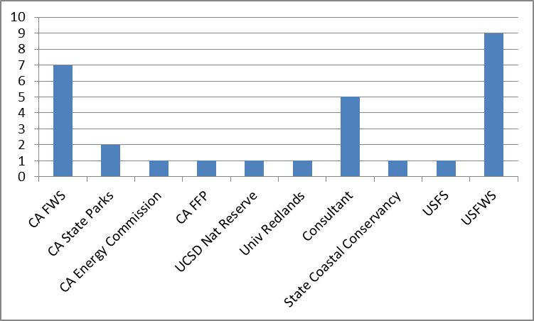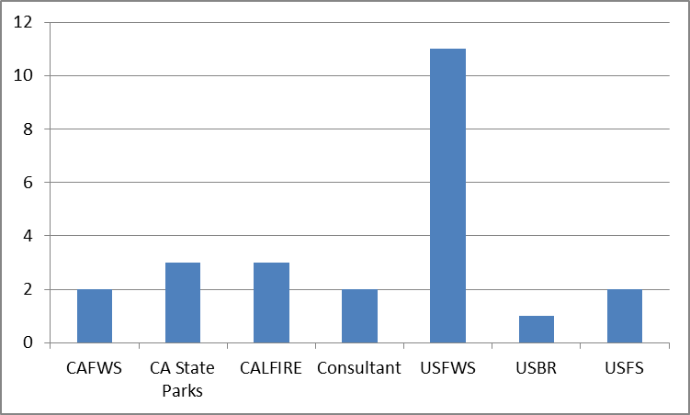
Non-technical course Technical course

Application of a Broad-Scale, Multi-Species Monitoring Program to Assess Shorebird Population Response to Future Land Use and Climate Change
- Developed draft workshop agenda to circulate to Joint Venture Partners and timeline for workshop completion
- Initiated collation of presentations for workshops and identified workshop participants

Using scenario planning to support climate-smart adaptation for the South Bay Salt Ponds Restoration Project: A case study for making science accessible to managers
- Work has begun to update our tidal marsh elevation models with the new 2 x 2 m digital elevation model.
- Working to schedule first meeting with the South Bay Sal Pond Project Management Team.

